DAY 1 ASSIGNMENT

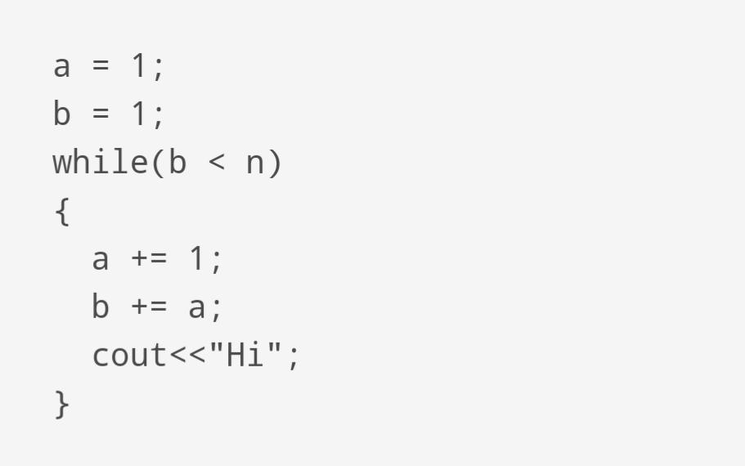

Answer:-

Since while loop is running for n times

T(n)=O(n)